**Award Tables**

# Geoff Anderson G3NPA and Aki Yoshida JA1NLX

## 1.0 GENERAL

Logger32 contains a comprehensive set of tables to display the statistics from the current logbook. Versions of Logger32, up to and including 2.3.0, have considered all entries to be QSOs and therefore included these into the awards table statistics. From version 2.4.0 onwards, a feature has been added to support incomplete QSOs (or heard, not worked QSOs).  Simply put an '=' at the end of the call, i.e., G3NPA= will appear as a QSO in the Logbook, but any data recorded will not show in any of the Stats.

**Note**: If you try to QSL a recorded callsign which contains the "=" character, Logger32 will advise you of the error:

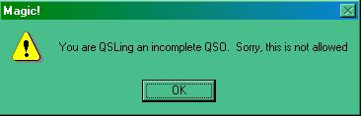

AT_1

W2RU - Bud Hippisley says-

*"The uses for this feature are numerous, and limited only by your imagination.  For instance, if you were accustomed to putting your CQs in your paper log (say you wanted a total record of when you were on the air, in anticipation of possible TVI complaints), you can now do that in Logger32 without it appearing as a QSO simply by entering 'CQ='.*

*Similarly, an informational log entry of WWV sunspot numbers no longer need show up as a spurious USA QSO; simply enter 'WWV=' and the data you wish to record."*

Also see the topic Logbook Informational Entries.

From version 3.19.0 a new system of award tracking was introduced to supplement the awards tables as a result of changes made to the ADIF specification. For more details on this particular aspect please refer to the topic Award Tracking.

The awards tables can be accessed through the Logger32 Main menu Awards menu option.

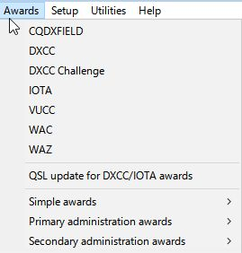

AT_2

The information available from each option is of a similar format so only one table is described here.

Awards are divided into three types namely

* + Simple;
  + Primary Administration; and,
  + Secondary Administration.

Primary and Secondary awards rely on data stored in the Primary (STATE) and Secondary (CNTY) ADIF fields.

Simple awards rely on data stored in one of the USER_X fields except for GridSquares, WPX and 10-10 award tables which use their own ADIF fields.

All awards tables show results for all bands but the 10-10 table need a special mention. Although the 10-10 awards table shows all bands, Only contacts made on 10M are valid and therefore only this column will be filled even if there are some records of 10-10 numbers against QSOs NOT on 10M in the logbook.

## 2.0 THE GENERAL AWARDS WINDOW

A typical Award Table is shown below. The data is shown on a per band basis as well as giving totals. Each band/country (or whatever) slot can show a (W)orked or (C)onfirmed flag. For some specific awards a credit (S)ubmitted or a credit (G)ranted flag can be shown. (An example of a “G” flag does not appear in the example below)

Selection of what is displayed can be refined further by the appropriate selection of the Mode, Operator and QSL type as desired.  What is available here is dependent on your own log and general set up.

The Stats reflected in this chart can be for the “Complete Logbook” or depicted by Calendar Year. User selection is by pulldown menu in the 5th pane. See the Worked/Confirmed window section for additional details

It is also possible in some tables to sort by column. Like all tables in Logger32, if any column header is in Red (as is PFX in AT_3 above), then the option exists for the user to change the sort order to another indexed column (in the case of the DXCC Awards, the user can also sort by Country or CQZ). Simply click on the column title to sort.

The band order (high to low, or low to high) is dependent on the menu setting TOOLS | AWARDS SETUP | SHOW BAND COLUMNS IN REVERSE ORDER.

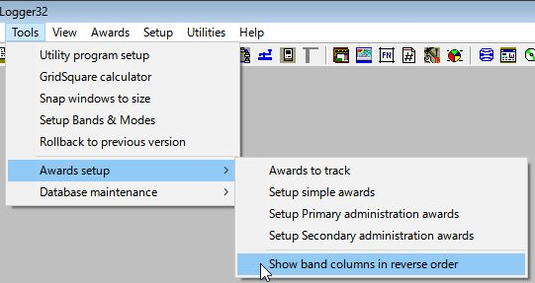

AT_2A

**Award table for DXCC**

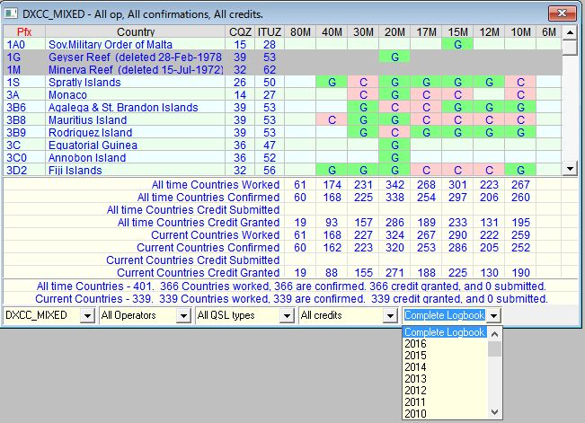

AT_3

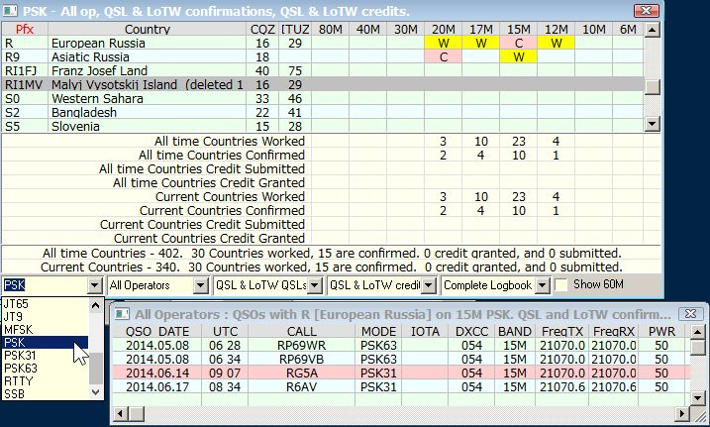

New AT_3AA

**Note**: The Annual stats option is available in CQDXFIELD, DXCC, DXCC Challenge ~~Chalenge~~, VUCC and GRID squares Award table.

**Note:** ~~DXCC stats are displayed by Mode, FT8, JT65 etc if user select Mode~~ If you operate PSK31 and PSK 63 you will see PSK as an option on the award mode drop down list. Click PSK, and it will list the combined PSK31 and PSK63 QSOs, or each submode can be listed individually.

You must put PSK31 and PSK63 slot in the”Setup Band & Mode” table.

**Award Table for WAS**

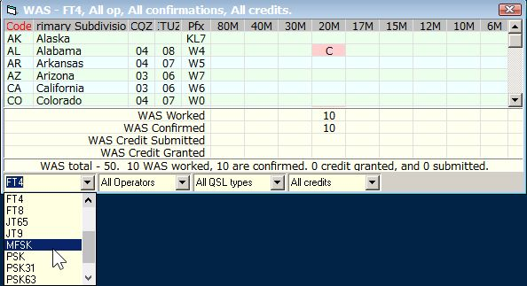

New AT_3AB

**Note:** ~~DXCC and WAZ stats are displayed by Mode, FT8, JT65 etc if user select Mode.~~ You must put FT4 slot (not MFSK) in the “Setup Band & Mode” table. If you click MFSK then you see stats for all submode of MFSK.

**Award Table for IOTA**

Standard IOTA (All HF Bands) award counts QSOs only on HF Bands. If you want to see VHF/UHF award then check “VHF/UHF”.